Name: Graham Wandless

Web Design Assets Inventory

1. Color Theme
   1. Primary color for block elements
      1. Name: dark red
      2. Hex (#) value and RGB:
         1. #6b0000
         2. rgb(107, 0, 0)
      3. Gradient values (if used)
   2. Secondary color for block elements
      1. Name: green
      2. Hex (#) value and RGB:
         1. #00bb00
         2. rgb(0, 187, 0)
      3. Gradient values (if used)
   3. Grayscale 1
      1. Name: black
      2. Hex (#) value and RGB:
         1. #000000
         2. rgb(0, 0, 0)
      3. Gradient values (if used)
   4. Grayscale 2
      1. Name: white
      2. Hex (#) value and RGB:
         1. #ffffff
         2. rgb(255, 255, 255)
      3. Gradient values (if used)
   5. Grayscale 3
      1. Name: grey
      2. Hex (#) value and RGB:
         1. #d3d3d3
         2. rgb(211, 211, 211)
      3. Gradient values (if used)
   6. Color(s) for body text
      1. Name: black
      2. Hex (#) value and RGB:
         1. #000000
         2. rgb(0, 0, 0)
      3. Background color hex(#): #ffffff
      4. Contrast ratio: 21:1
   7. Color(s) for display text
      1. Name: black
      2. Hex (#) value and RGB:
         1. #000000
         2. rgb(0, 0, 0)
      3. Background color hex(#): #ffffff
      4. Contrast ratio: 21:1
   8. Color(s) for header text
      1. Name: white
      2. Hex (#) value and RGB:
         1. #ffffff
         2. rgb(255, 255, 255)
      3. Background color hex(#): #6b0000
      4. Contrast ratio: 12.92:1
   9. Color for submit button 1
      1. Name: grey
      2. Hex (#) value and RGB:
         1. #d3d3d3
         2. rgb(211, 211, 211)
      3. Gradient values (if used)
   10. Color for submit button 2
       1. Name: lightgreen
       2. Hex (#) value and RGB:
          1. 90ee90
          2. rgb(144, 238, 144)
       3. Gradient values (if used)
   11. Color for submit button 3
       1. Name: green
       2. Hex (#) value and RGB:
          1. 008000
          2. rgb(0, 128, 0)
       3. Gradient values (if used)
2. Typography
   1. Display font family: Raleway
      1. Weights (thin, regular, bold, etc): Bold
      2. Styles (italic)
   2. Body font family: Crimson Text
      1. Weights (thin, regular, bold, etc): Regular
      2. Styles (italic): Regular Italic
   3. Heading(s) h1-h6 (list all)
      1. Font-family: Raleway
      2. Font-size:
      3. Weight: Bold
      4. Style
   4. Drop Cap
      1. Font-family: Crimson Text
      2. Font-size: 240%
      3. Weight: Regular
      4. Style: Regular
3. Imagery
   1. Profile
      1. Photo alt text: This is a picture of me.
      2. Caption
      3. Filename & Link: image_of_me-xsmall.jpg
   2. Gallery Image 1
      1. Photo alt text: Itty in a cat tunnel.
      2. Caption: Itty in a cat tunnel.
      3. Filename & Link: itty1-xsmall.jpg
   3. Gallery Image 2
      1. Photo alt text: Itty on a chair.
      2. Caption: Itty on a chair.
      3. Filename & Link: itty2-xsmall.jpg
   4. Gallery Image 3
      1. Photo alt text: Itty on my lap.
      2. Caption: Itty on my lap.
      3. Filename & Link: itty3-xsmall.jpg
   5. Gallery Image 4
      1. Photo alt text: Itty looking up at me.
      2. Caption: Itty looking up at me.
      3. Filename & Link: itty4-xsmall.jpg
   6. Gallery Image 5
      1. Photo alt text: Itty on a pillow.
      2. Caption: Itty on a pillow.
      3. Filename & Link: itty5-xsmall.jpg
   7. Gallery Image 6
      1. Photo alt text: Itty on a rug.
      2. Caption: Itty on a rug.
      3. Filename & Link: itty6-xsmall.jpg
4. Iconography
   1. Logo
      1. Picture (svg)
      2. Filename & Link: logo.svg
   2. Favicon
      1. Picture (png)
      2. Filename & Link: favicon-32x32.png
   3. HTML icons (list all that are used)
      1. Icon font for GitHub link
         1. Icon: <https://fontawesome.com/icons/github?style=brands>
         2. Unicode: f09b
         3. HTML: <i class="fab fa-github"></i>
      2. Icon font for others 1
         1. Icon: fa-bars
         2. Unicode: f0c9
         3. HTML: <i id="symbol-toggle" class="fas fa-bars"></i>
      3. Icon font for others 2
         1. Icon: fa-times
         2. Unicode: f00d
         3. HTML: <i id="symbol-toggle" class="fas fa-times"></i>
5. Form
   1. Input
      1. Unfocused styles: default
      2. Focused styles:

background: rgba(0, 0, 0, .05);

border-radius: 0.3125rem;

outline: none;

* 1. Textarea
     1. Unfocused styles: default
     2. Focused styles:

background: rgba(0, 0, 0, .05);

border-radius: 0.3125rem;

outline: none;

* 1. Radio Buttons
     1. Unfocused styles: default
     2. Focused styles:

background: rgba(0, 0, 0, .05);

border-radius: 0.3125rem;

outline: none;

1. Submit Button
   1. Background color: lightgrey
   2. Border: default
   3. Font-family: Crimson Text
   4. Font-size: 120%
   5. Weight: 400
   6. Hover behavior: turns grey over 0.25 seconds
   7. Click behavior: turns lightgreen over 0.25 seconds
   8. Resource: <https://www.w3schools.com/css/css3_transitions.asp>
2. Drop cap
   1. CSS code:

.dropcap {

font-size: 240%;

line-height: 1;

float: left;

margin-right: 0.25rem;

}

* 1. Resource: <https://htmldog.com/techniques/dropcaps/>

1. Blog Topic(s)
   1. Chosen topic: CSS Animation
   2. Resources:
      1. <https://www.w3schools.com/css/css3_animations.asp>
      2. <https://developer.mozilla.org/en-US/docs/Web/CSS/CSS_Animations/Using_CSS_animations>
   3. Draft visual example. Provide a short description of your example.
      1. It begins as a red square. It then moves to the right, becomes circular, and turns green. Then it moves to the center and turns purple. Next it moves down, increases in width, and turns blue. Finally, it moves back to its starting position, while rotating 360 degrees, returning to its original width, becoming square again, and turns red, before repeating.

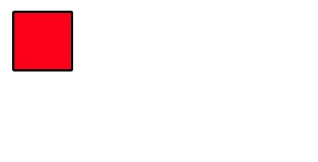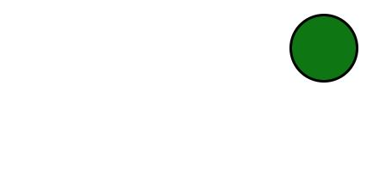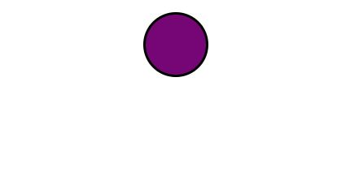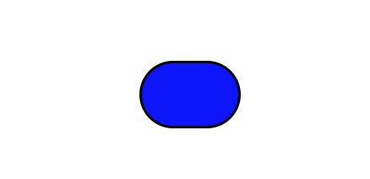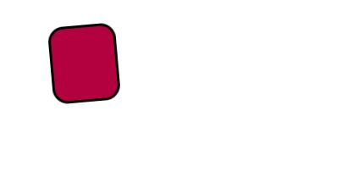

1. Extra Credit (list all that apply)
   1. Deliverable: custom logo
      1. Provide a short description of what is included: a custom logo that I created
      2. Resources: vecteezy
   2. Deliverable: additional gallery photos
      1. Provide a short description of what is included: additional gallery photos, that display responsively